Enhancing Shadows in T-34 vs. Tiger: A Simple Modding Guide

Murkz Fri 23 Feb 2024 - 18:37
In the world of T-34 vs. Tiger, a game that long ago captured the imaginations of tank simulation enthusiasts, even the smallest modifications can significantly enhance the gaming experience. Today, I'd like to share a simple yet impactful tweak that improves the rendering distance of shadows for vehicles and buildings, bringing a new level of depth and realism to the game's graphics.
While exploring the game's files, I stumbled upon a parameter in the content.script file that controls the distance at which shadows from vehicles and buildings are rendered. The default setting was somewhat limiting, with shadows only appearing within a 300-unit radius. By adjusting this value, we can significantly extend the shadow rendering distance, adding to the game's immersive quality.
Making the Change
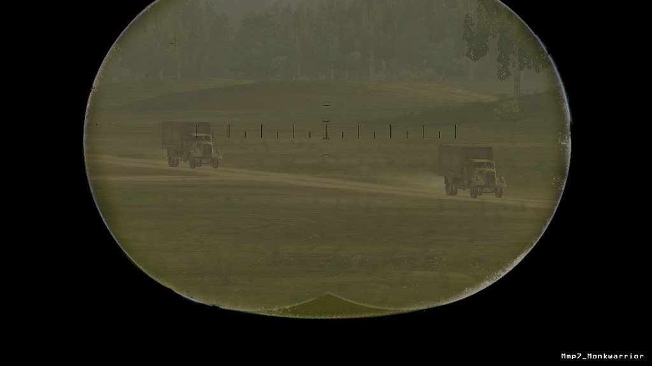
Here's how you can apply this modification to your own game:
Locate the content.script file within the game's missions directory. This file contains various settings that control the game's visual aspects.
Open the file with a text editor of your choice (Notepad++).
Search for the ShadowFar parameter. You'll find it set to a default value of 300.000000.
Change this value to 900.000000. This increases the shadow rendering distance, allowing shadows from vehicles and buildings to be visible from much further away.
Save your changes and launch the game to see the effects.
plaintext
["ShadowFar", 900.000000] // Original: 300.000000,
The Result
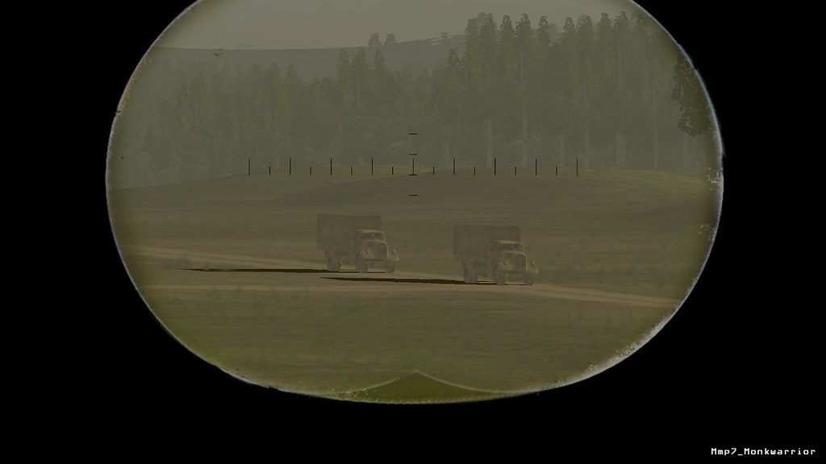
The immediate effect of this modification is a more visually appealing and realistic battlefield. Vehicles and buildings now cast, dynamic shadows, enhancing the overall immersion of the game. Importantly, this tweak does not impact the game's performance on modern hardware, making it a must-try for any T-34 vs. Tiger fan looking to improve their visual experience.
T-34 vs. Tiger, despite its age, continues to offer a deeply engaging tank simulation experience. Through simple modifications like this, you can still breathe new life into the simulator, further enhancing the enjoyment and appreciation for this classic title. I encourage you to experiment with the content.script file and explore other ways to customize your game.
Happy modding!

